**User Role Request – End user Guide**

#### Table of Contents

Contents

About this Document 3

Overview of the process 3

Create and track a new request: 4

Request Approval 9

Delegation Setup: 10

Add Temporary Roles Details: 11

# ****About this Document****

**The purpose of this document is to describe the steps and processes required to create, manage and approve user role requests in NetSuite.**

**Any employee who is required to create, manage and approve User Role Requests (URR) should read this document and follow the process steps described. It is advisable to have spoken with your manager before submitting the request to ensure a speedy process.**

# **Overview of the process**

**This process is to cater for requests for NetSuite roles and excludes any ‘Misys Employee Center’ roles. For ‘Employee Center’ roles the user should complete the basic online training for NetSuite, which are available on MiCareer. Once training is completed, the service desk team will provide the ‘Employee Center’ access within 24 hours.**

**Please note, employee center access provides the user ability to raise PO, receipt PO, create vendor request and setup delegation.**

**In order to make a new access request, you will need to use the ‘Misys Employee Center-General’ role. This is a workflow managed task starting with the creation of a request by the user followed by a range of approvals (supervisor, role owner, Internal Audit (if required), Exception Approver (if required)). The revised process also covers the situation where a role is only required on a temporary basis. All approvers will manage the process using their Employee Center role. Once fully approved, the request will pass to the NS-Admin team for access to be granted. Once fully processed, the system will trigger an email to the requester with the list of roles provided to them and the action will be closed.**

**At the time of raising new request you have options to add two types of roles:**

1. **Permanent Role: The role(s) which you need on the daily basis and doesn’t have and end date for the use of that role. Example: You are a member of Account Payable team and accounting invoices is your day-to-day task for which you need ‘Misys Account Payable Invoice Clerk_SAML’ role than this role will fall under Permanent role.**

**Click** here **to know more about permanent role Fields.**

1. **Temporary Roles: The role(s) which you need to complete any time based activity should fall under this category. Example: You are a member of AP team and your day-to-day task is to account the invoices but for a specified time period you have additional responsibility of indexing the invoices and need ‘Misys Vendor Invoice Upload_SAML’ role as well. In that case you need to add that role under temporary role section.**

**Click** here **to know, how to add a temporary role in request.**

There are a number of ‘Custom Features’ within this process with details below.

-**My Access Requests**, shows all requests which are either created by you or requested on behalf of you.

-**Create New Access request**, this will open up the form for creation of new access request.

-**Help Document**, this will allow user to download the help document.

-**Accesses pending for my approval**, this will open the page with details of requests which are ‘Pending for Approval’ in your task list.

# Create and track a new request:

# **To create a new role request user need to follow the following steps.**

1. Login to NetSuite using ‘Misys Employee Center-General’ role.
2. Go to ‘Custom Features >> Access Details >> Create New Access Request’.

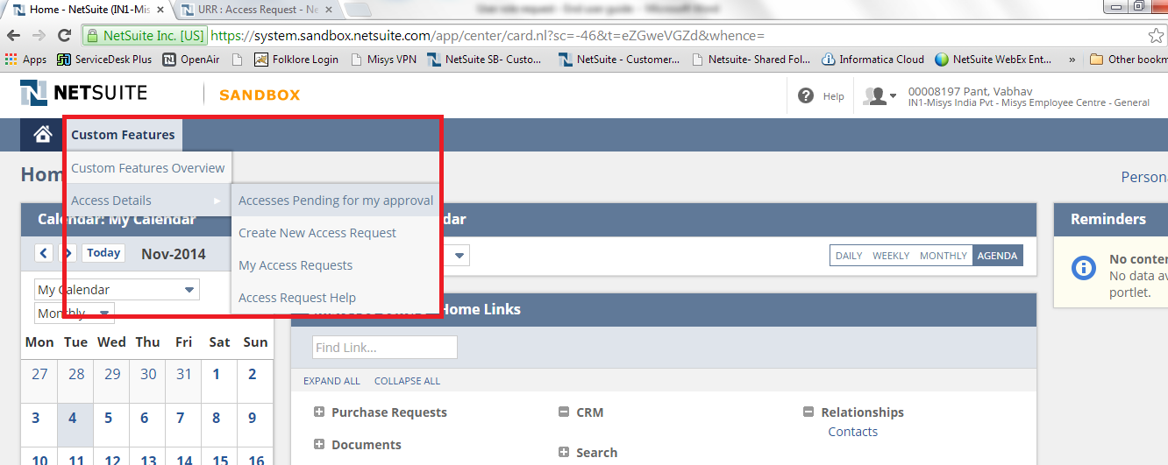

1. **Clicking on ‘Create New Access Request’ will open the form below. All the highlighted fields will come with default values.**

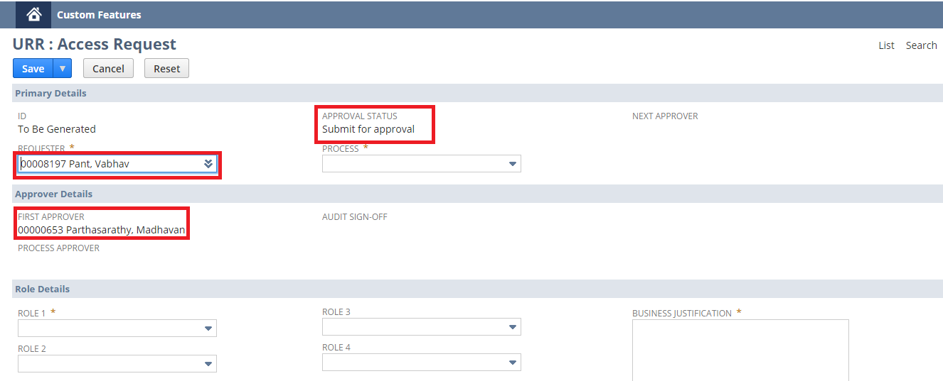

**Below are the definitions of various fields available on the form.**

**Requester –The Logged in user’s name is the default value for this field. If required, the user can change this. This should only be done in exceptional circumstances.**

**‘First Approver’ (Requester’s Supervisor) field will be populated based on this selection.**

**Process –Roles are managed against business processes. There are 11 listed processes as at June 2015, these may be amended in the future (e.g. Accounts Payable, Procurement etc.). This field will populate all the options available and based on the process selection here user will see the role list available in Role 1, 2..., 4.**

**Attached file contains role-process mapping.**

**Business Justification -Text area field (mandatory), to provide business justification.**

**E.g. Requester has been transferred from Account Payable team to R2R and hence role changes are required as suggested or the individual has taken a new business role.**

**Process Approver / Audit Sign off These fields will populate depending on process selected (see section on Approvals).**

**Role 1, 2, 3, 4 –These fields have drop down values for each process. For example, if ‘Procurement’ is the selected process, the dropdown will show all the roles pertaining to the ‘Procurement’ process.**

**‘Role-Process grouping.xlsx’ file can be referred to confirm role-process mapping.**

1. **Once all the required fields have been filled in, the user should save the record. Upon hitting ‘Save’ the system will redirect the user to the ‘Current roles’ page. This page will display all the roles, currently assigned to the requester. Here the user MUST select the roles he/she wants to continue with.**

* **User need to check the boxes in front of role, if role is required.**
* **If user left box unchecked, role will be revoked by NS-Admin team at the time of request processing.**

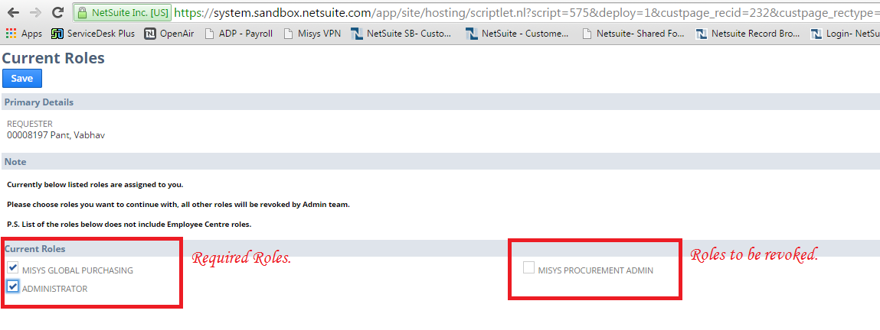

1. Once the selection on the ‘Current Roles’ page has been completed, the user will be redirected to the request screen. Options available here will be:
2. **Submit for approval**: Clicking this will push the request forward for approval.
3. **Change Current roles’ selection:** Clicking this will take user back to ‘Current Roles’ page.

If user wants to make any changes to request form, the same can be made if the request has not been submitted for approval. Once user clicked ‘Submit for approval’ button, request will be locked and won’t be available for editing.

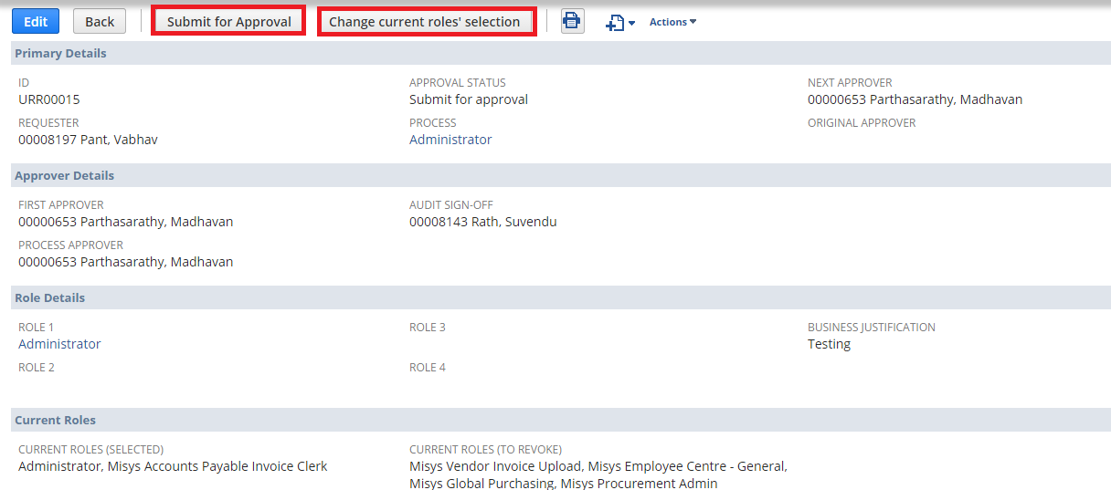

1. **It’s mandatory that the requester check ‘Read Confirmation’ box and if a role is required on a temporary basis, user have to complete the additional step described in the section ‘Add temporary roles’. Please click** here **to find, how to add temporary role details.**
2. **Submitting the request for approval will lock the record and send it for first level approval, which is the employee’s supervisor. Once approved by the supervisor the request will go for further approvals based on the defined process workflow.**

**Note:**

* **Upon submission of the request, an email will be triggered to the requester as well as to the creator (if different). Each request will have a unique number, which can be used for any following up.**
* **We recommend that users follow up on any system email without removing the sender’s email id (i.e. just reply). This will help the system to log conversations within the request.**
* **Once the request is submitted the user can trace the progress of the request in the ‘Next Approver’ field.**

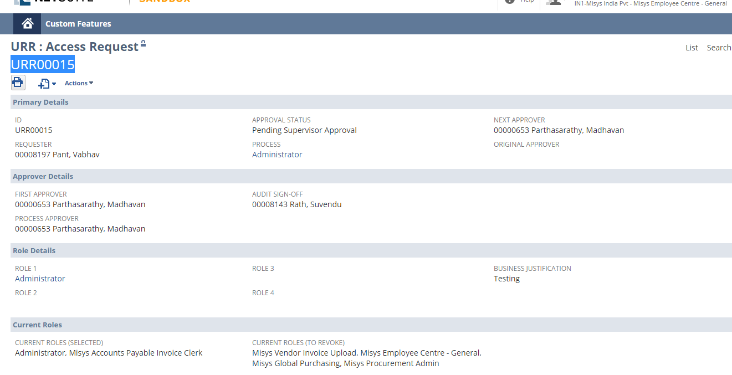

1. **Once approved by all the approvers the request will pass to the NS-Admin team for processing. The status will change to ‘Approved/Pending Processing’.**

**Note: ‘Access Granted’ button will only be displayed to members of the IS Admin team.**

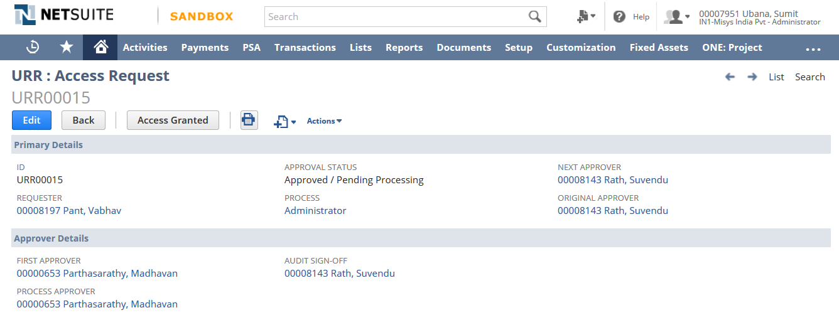

1. **Once the access is processed by the NS-Admin team an email will be triggered automatically to the requester and creator with the details of the roles provided and the record status will change to ‘Approved / Access Granted’.**

**Note: If an access request is rejected at any stage of the process, an email will be triggered to the requester with the details of rejection and they should review and discuss with their manager before processing additional requests.**

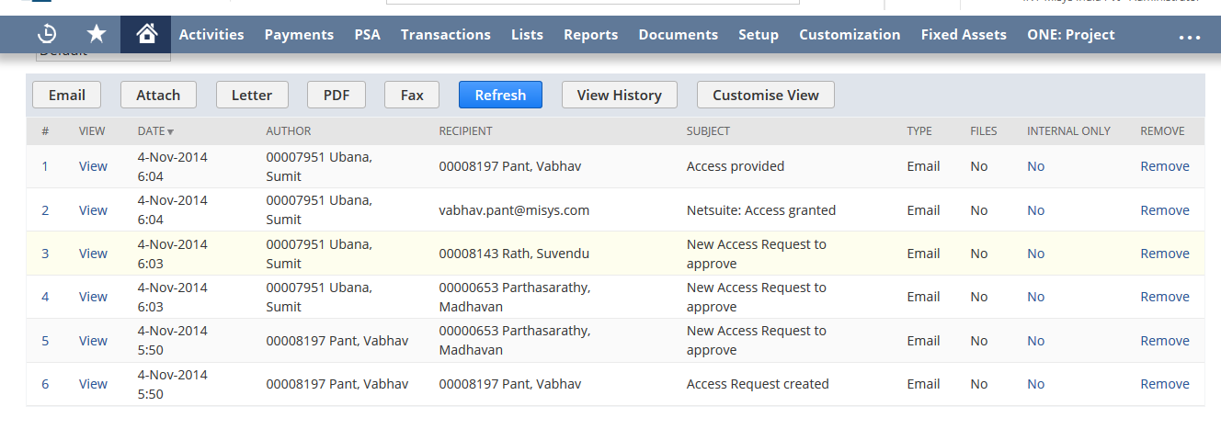

# Request Approval

**There are two basic levels of approval for role requests.**

* **First Approver: This will always be requester’s supervisor.**
* **Process Approver: This will be business owner of the selected process.**

**In addition there may be other approvals required to complete the controls process:**

* **Internal Control Approval: This is required in following scenario.**

**> All role requests (new, change) except roles listed under procurement process requested by “other than” finance department.**

* **Exception approval: the additional approval here depends on a number of selected processes or roles which are considered as high risk. Steps to approve:**

**Below are the steps the user needs to follow in order to approve requests.**

1. Login to NetSuite using ‘Misys Employee Center-General’ role.
2. Go to **‘Custom Features >> Access Details >> Accesses pending for my approval’**.

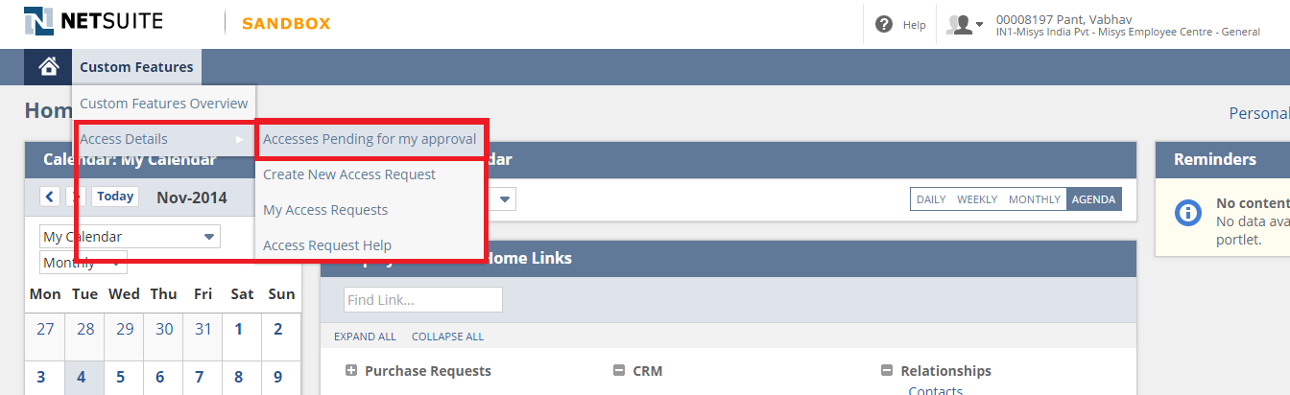

1. **This will open up all the requests pending for your approval. Once the list is open you can choose them one by one and can approve/reject.**

**Note: Rejection will transfer the approver to a ‘Rejection Details’ screen. Once the user has completed the rejection reason, this will be visible on the request and passed back to the original requester.**

Delegation Setup: **An approver can delegate his/her approval rights in his absence.** **This can be done in two ways.**

**1) Users can setup delegation by themselves using the ‘Misys Employee Center - General’ role. To setup the delegation user need to fill Employee, Delegate, ‘Date From’ and ‘Date To’ and current date fields before submitting delegation form. Delegation will be revoked automatically after ‘Date To’.**

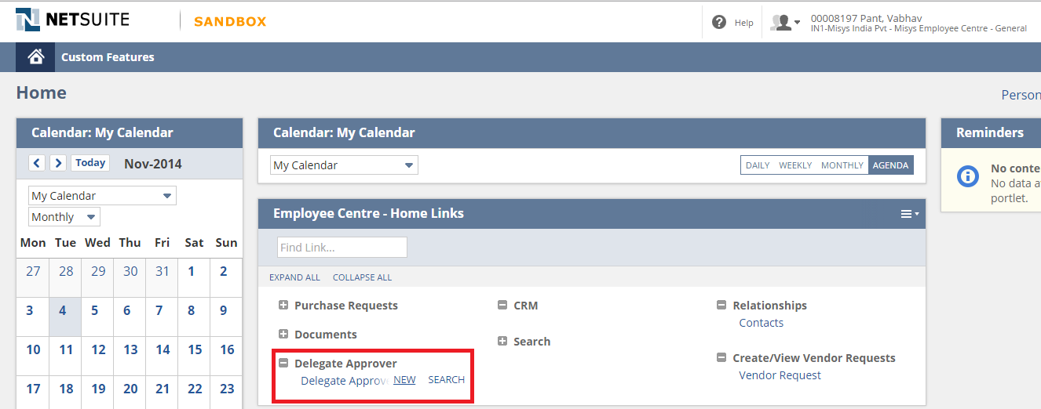

* **2) If the user is on leave and has not setup any delegation, the supervisor can raise a Service Desk request (** [**Servicedesk Catalogue**](http://servicedesk/Templates.do?SkipNV2Filter=true&SkipNV2Filter=true&module=mergedRequest)**).**

Approve requests as delegate: **Once a delegation process is setup, all the requests which are pending with an employee will be transferred to the delegate for approval. The user should follow the process steps as described in the ‘Approve a request’ section above.**



# Add Temporary Roles Details:

**Once the requester has saved the user role request, temporary roles details can be added to the request. The requester needs to use following steps for this:**

1. **Go to ‘Temporary Roles’ tab and click ‘New URR: Temporary Role’ button.**

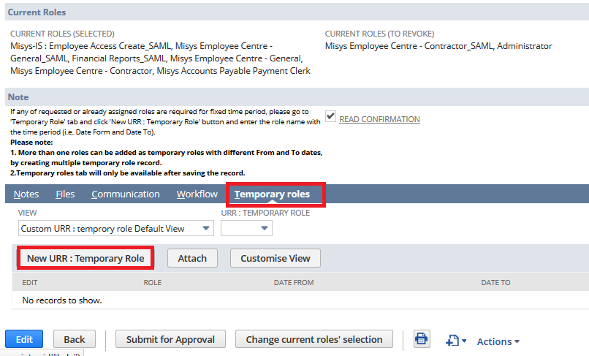

1. **Above action will open page below. The requester needs to fill all the available fields and save the form.**

**Below are the definitions of various fields available on the form.**

* + **Role: The requester should select name of the temporary role here.**
  + **Date From: The requester needs to select date for assignment of selected role.**
  + **Date To: Role will be removed by IS team on the next day of the date selected here.**
  + **Memo: This field can be used for information which user feels could be helpful to understand the purpose of role.**

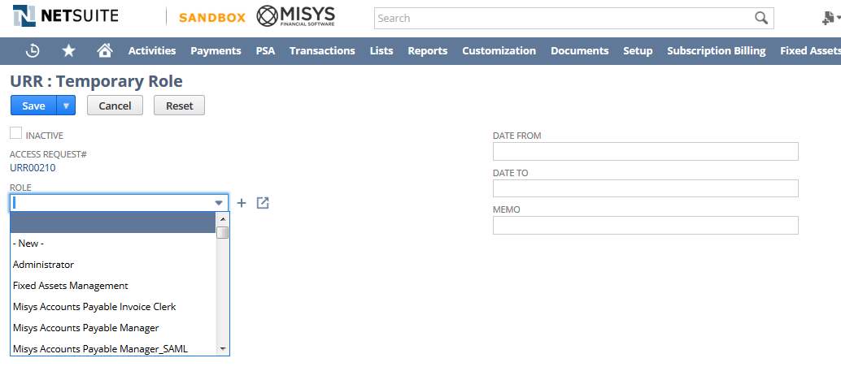

1. **Once completed the requester need to hit ‘Save’ button. This action will save the form and link it with the user request.**

**Created record will be available under ‘Temporary roles’ tab.**

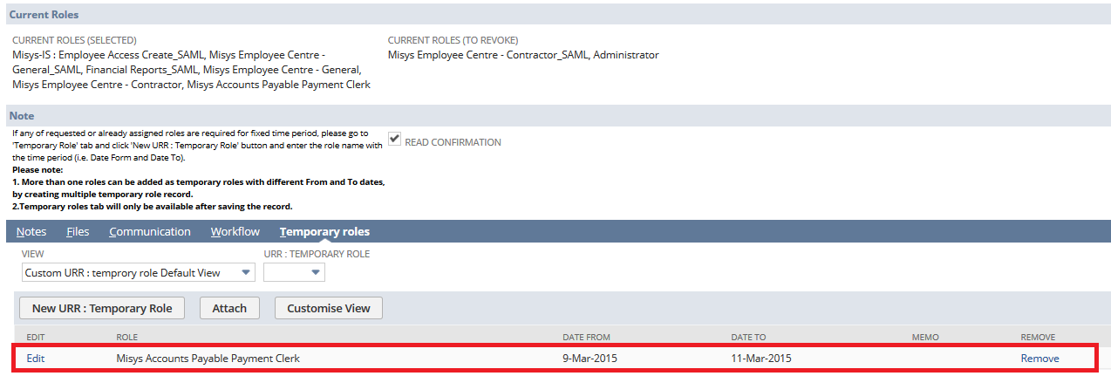

**Note:**

* **The role which the requester has selected under temporary role record should be one of the assigned or requested roles.**
* **The requester can add multiple temporary roles under a single request.**